Setup Ansible host and try to configure basic ping and shell modules on command line itself.

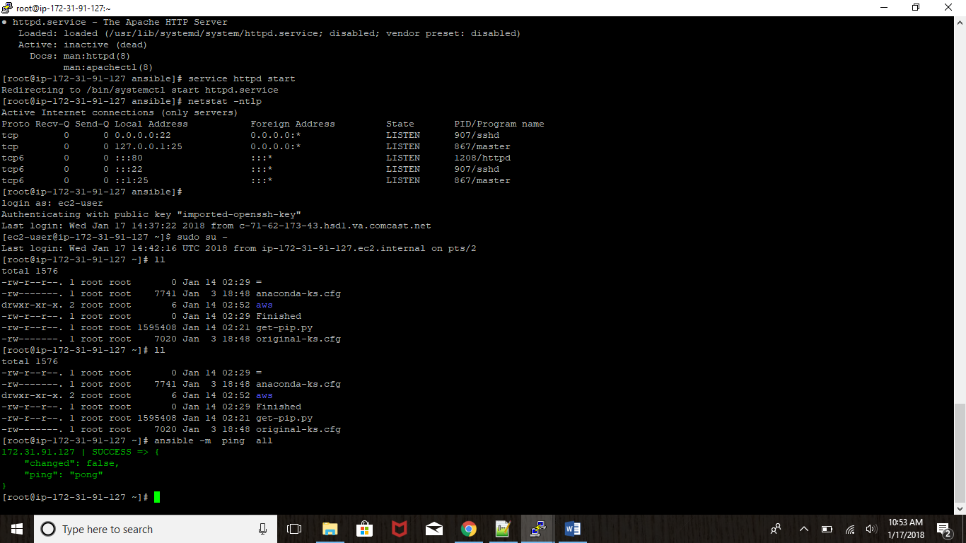

Hen try to create a basic playbook for installing Ubuntu/yum packages on server using basic Ansible playbook.

- name: Install yum packages using a list

yum:

name:

- git

- sshpass

- openssl-devel

